**Location: Online housingcounseling.caclv.org**

**VIRTUAL FIRST TIME HOME BUYER SEMINAR**

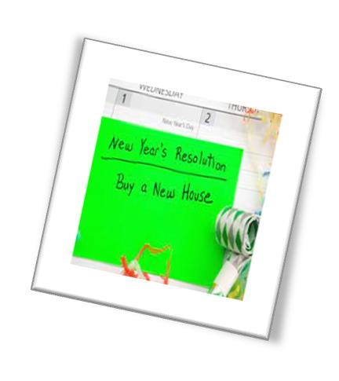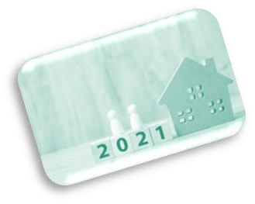

**8:00 am to 1:00 pm pm**

**HOCP English**

**Seminar**

**January**

**8**

**and**

**January**

**1**

**5**

**,**

**202**

**2**



**To register call 484-893-1063**



Housing Counseling

Program

Community Actio

n

Lehigh Valley

1337

East Fifth Street

Bethlehem, PA 18015

