RESOLUTION NO.__________

RE: CERTIFICATE OF APPROPRIATENESS UNDER THE
PROVISIONS OF THE ACT OF THE PENNSYLVANIA
LEGISLATURE 1961, JUNE 13, P.L. 282 (53
SECTION 8004) AND BETHLEHEM ORDINANCE NO.
3952 AS AMENDED.

WHEREAS, it is proposed secure a COA to install a gate for access to the courtyard area from the Greenway at 321 Adams Street (Brinker Lofts).

NOW, THEREFORE, BE IT RESOLVED by the Council of the City of Bethlehem that a Certificate of Appropriateness is hereby granted for the proposal.

Sponsored by: (s)

(s)

ADOPTED BY COUNCIL THIS DAY OF

(s)
President of Council

ATTEST:

(s)
City Clerk

HISTORIC CONSERVATION COMMISSION

CASE #709 -- It is proposed to install a gate for access to the courtyard area from the Greenway at 321 Adams Street (Brinker Lofts).

OWNER / APPLICANT: Bethlehem-Adams, LLC / Charles Jefferson

The Commission upon motion by Ms. Starbuck and seconded by Mr. Silvoy adopted the proposal that City Council issue a Certificate of Appropriateness for the proposed work as presented, with modifications described herein:

- The proposal to install a gate for access to the courtyard area from the Greenway at 321 Adams Street was presented by Duane Wagner.
- Approved design of the new gate includes the following details:
  - simple rails and pickets fabricated in aluminum with square cross-sections to match fence design previously approved elsewhere at project site
  - two gate segments to measure between 6-feet and 6-feet 6-inches high; each gate segment is 6-feet wide
  - pickets will be punched through horizontal rails for structural stability; intermediate rails and cross-bracing are also approved, as needed
  - simple top spikes at top rail (as security measure) will align with vertical pickets
  - gates will swing to open and to close; business hours of operation will dictate when gates are open
- The Applicant agreed to submit to-scale drawings of the finalized gate design via the City of Bethlehem for approval by the Historic Officer and the HCC Chair prior to purchase and installation.
- The motion for the proposed work was unanimously approved.

JBL: jbl
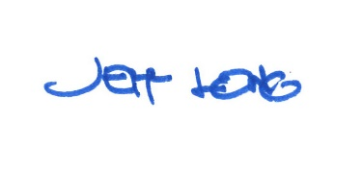

By:

Date of Meeting: December 16, 2019

