RESOLUTION NO.__________

RE: CERTIFICATE OF APPROPRIATENESS UNDER THE
PROVISIONS OF THE ACT OF THE PENNSYLVANIA
LEGISLATURE 1961, JUNE 13, P.L. 282 (53
SECTION 8004) AND BETHLEHEM ORDINANCE NO.
3952 AS AMENDED.

The applicant proposes to install vinyl/decal store signage on two windows at
1 East Church St.

NOW, THEREFORE, BE IT RESOLVED by the Council of the City of Bethlehem that a Certificate of Appropriateness is hereby granted for the proposal.

Sponsored by: (s)

(s)

ADOPTED BY COUNCIL THIS DAY OF

(s)
President of Council

ATTEST:

(s)
City Clerk

HISTORICAL & ARCHITECTURAL REVIEW BOARD

The applicant proposes to install vinyl/decal store signage on two windows at 1 East Church St.

APPLICATION #2:

Genevieve Marcon
55 E. Church St.
Bethlehem, PA 18018

OWNER:

__________________________________________________________________________

The Board upon motion by Beth Starbuck and seconded by Connie Glagola adopted the proposal that City Council issue a Certificate of Appropriateness for the following:

1. All sign lettering shall be a serif style.

2. There should be an additional space between the words VEG and OUT.

3. If they alter the design, they must re-submit an application.

4. The motion was unanimous to approve.

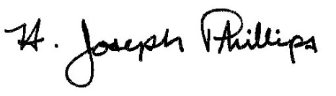 By:__ H. Joseph Phillips___________
Title: _Historic Officer____________
Date of Meeting: December 4, 2019

