RESOLUTION NO.__________

RE: CERTIFICATE OF APPROPRIATENESS UNDER THE
PROVISIONS OF THE ACT OF THE PENNSYLVANIA
LEGISLATURE 1961, JUNE 13, P.L. 282 (53
SECTION 8004) AND BETHLEHEM ORDINANCE NO.
3952 AS AMENDED.

The applicant proposes to install vinyl/decal store signage at 99 W. Broad St.

NOW, THEREFORE, BE IT RESOLVED by the Council of the City of Bethlehem that a Certificate of Appropriateness is hereby granted for the proposal.

Sponsored by: (s)

(s)

ADOPTED BY COUNCIL THIS DAY OF

(s)
President of Council

ATTEST:

(s)
City Clerk

HISTORICAL & ARCHITECTURAL REVIEW BOARD

The applicant proposes to install vinyl/decal store signage at 99 W. Broad St.

APPLICATION #1:

Arthur Schmidt
99 W. Broad St.
Bethlehem, PA 18018

OWNER:

__________________________________________________________________________

The Board upon motion by Beth Starbuck and seconded by Marsha Fritz adopted the proposal that City Council issue a Certificate of Appropriateness for the following:

1. The decal signage shall be placed in the middle of the stores bay windows as
prepared by FASTSIGNS.

2. The motion was unanimous to approve.

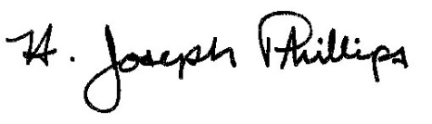 By:__ H. Joseph Phillips___________
Title: _Historic Officer____________
Date of Meeting: December 4, 2019

