RESOLUTION NO.__________

RE: CERTIFICATE OF APPROPRIATENESS UNDER THE
PROVISIONS OF THE ACT OF THE PENNSYLVANIA
LEGISLATURE 1961, JUNE 13, P.L. 282 (53
SECTION 8004) AND BETHLEHEM ORDINANCE NO.
3952 AS AMENDED.

It is proposed to install outdoor lighting, concrete parking pad and a small deck at 30 E. Wall St.

NOW, THEREFORE, BE IT RESOLVED by the Council of the City of Bethlehem that a Certificate of Appropriateness is hereby granted for the proposal.

Sponsored by: (s)

(s)

ADOPTED BY COUNCIL THIS DAY OF

(s)
President of Council

ATTEST:

(s)
City Clerk

HISTORICAL & ARCHITECTURAL REVIEW BOARD

It is proposed to install outdoor lighting, concrete parking pad and a small deck at 30 E. Wall St.

APPLICATION #6:

Christian Barrett
30 E. Wall St.
Bethlehem, PA 18018

OWNER:

__________________________________________________________________________

The Board upon motion by Phil Roeder and seconded by Beth Starbuck adopted the proposal that City Council issue a Certificate of Appropriateness for the following:

1. Outdoor lighting shall be traditional, shorter, mushroom style fixture.

2. Lighting fixtures on the rear wall shall be located lower on the wall and closer to
the foundation so not seen from the street.

3. Concrete parking pad will be approx.. 18’ wide by 30’ long and extend the full length
of the fence, from the fence to the street.

4. The deck will be 10’x 10’ Ipe wood with a clear sealant and flush with the adjacent
brick and landscaping surfaces.

5. The dryer vent on the rear wall will be painted to match the brick wall surface.

6. The motion was unanimous to approve.

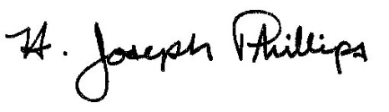 By:__ H. Joseph Phillips___________
Title: _Historic Officer____________
Date of Meeting: November 6, 2019

