RESOLUTION NO.__________

RE: CERTIFICATE OF APPROPRIATENESS UNDER THE
PROVISIONS OF THE ACT OF THE PENNSYLVANIA
LEGISLATURE 1961, JUNE 13, P.L. 282 (53
SECTION 8004) AND BETHLEHEM ORDINANCE NO.
3952 AS AMENDED.

It is proposed to install exterior lighting at the entryway to highlight tenant’s
signage at 444 Main St.

NOW, THEREFORE, BE IT RESOLVED by the Council of the City of Bethlehem that a Certificate of Appropriateness is hereby granted for the proposal.

Sponsored by: (s)

(s)

ADOPTED BY COUNCIL THIS DAY OF

(s)
President of Council

ATTEST:

(s)
City Clerk

HISTORICAL & ARCHITECTURAL REVIEW BOARD

It is proposed to install exterior lighting at the entryway to highlight tenant’s signage at 444 Main St.

APPLICATION #5:

Moravian College
444 Main St.
Bethlehem, PA 18017

OWNER:

__________________________________________________________________________

The Board upon motion by Beth Starbuck and seconded by Diana Hodgson adopted the proposal that City Council issue a Certificate of Appropriateness for the following:

1. The gooseneck lighting fixtures will be black in color.

2. The light temperature shall be 270 Kelvin.

3. The motion was unanimous to approve.

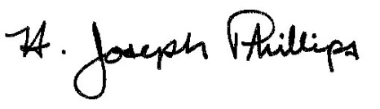 By:__ H. Joseph Phillips___________
Title: _Historic Officer____________

Date of Meeting: November 6, 2019

