RESOLUTION NO.__________

RE: CERTIFICATE OF APPROPRIATENESS UNDER THE
PROVISIONS OF THE ACT OF THE PENNSYLVANIA
LEGISLATURE 1961, JUNE 13, P.L. 282 (53
SECTION 8004) AND BETHLEHEM ORDINANCE NO.
3952 AS AMENDED.

It is proposed to re-install the existing gate at the entrance and install new fencing at 2 W. Market St.

NOW, THEREFORE, BE IT RESOLVED by the Council of the City of Bethlehem that a Certificate of Appropriateness is hereby granted for the proposal.

Sponsored by: (s)

(s)

ADOPTED BY COUNCIL THIS DAY OF

(s)
President of Council

ATTEST:

(s)
City Clerk

HISTORICAL & ARCHITECTURAL REVIEW BOARD

It is proposed to re-install the existing gate at the entrance and install new fencing at 2 W. Market St.

APPLICATION #4:

Herm & Claire Rij
2705 Bridel Path Place
Bethlehem, PA 18017

OWNER:

__________________________________________________________________________

The Board upon motion by Marsha Fritz and seconded by Rodman Young adopted the proposal that City Council issue a Certificate of Appropriateness for the following:

1. Re-install an existing gate at the entrance of the existing access drive.

2. Install new fencing to match existing along the east side of the property.

3. The color of the gate and fence are to match the exiting.

4. The motion was unanimous to approve.

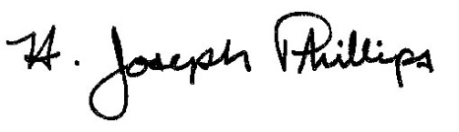 By:__ H. Joseph Phillips___________
Title: _Historic Officer____________
Date of Meeting: November 6, 2019

