RESOLUTION NO.__________

RE: CERTIFICATE OF APPROPRIATENESS UNDER THE
PROVISIONS OF THE ACT OF THE PENNSYLVANIA
LEGISLATURE 1961, JUNE 13, P.L. 282 (53
SECTION 8004) AND BETHLEHEM ORDINANCE NO.
3952 AS AMENDED.

The applicant proposes to install a bracket and hanging sign at 77 W. Broad St.

NOW, THEREFORE, BE IT RESOLVED by the Council of the City of Bethlehem that a Certificate of Appropriateness is hereby granted for the proposal.

Sponsored by: (s)

(s)

ADOPTED BY COUNCIL THIS DAY OF

(s)
President of Council

ATTEST:

(s)
City Clerk

HISTORICAL & ARCHITECTURAL REVIEW BOARD

It is proposed to install bracket and hanging sign at 77 W. Broad
Street.
APPLICATION #3:

West Broad LLC
77 W. Broad St.
Bethlehem, PA 18018

OWNER:

__________________________________________________________________________

The Board upon motion by Diana Hodgson and seconded by Marsha Fritz adopted the proposal that City Council issue a Certificate of Appropriateness for the following:

1. The body of the sign shall be bone white with the letters black.

2. The straw graphic shall be PM 376 (green).

3. All fasteners shall be placed in the mortar joints not in the brick.

4. The sign shall be 30” in diameter with new metal bracket.

5. The motion was unanimous to approve.

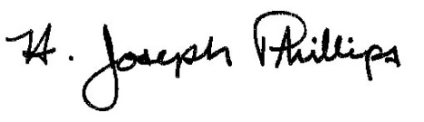 By:__ H. Joseph Phillips___________
Title: _Historic Officer____________
Date of Meeting: November 6, 2019

