RESOLUTION NO.__________

RE: CERTIFICATE OF APPROPRIATENESS UNDER THE
PROVISIONS OF THE ACT OF THE PENNSYLVANIA
LEGISLATURE 1961, JUNE 13, P.L. 282 (53
SECTION 8004) AND BETHLEHEM ORDINANCE NO.
3952 AS AMENDED.

The applicant proposes to install a double-sided blade sign at 530 Main St.
(Clusters Popcorn).

NOW, THEREFORE, BE IT RESOLVED by the Council of the City of Bethlehem that a Certificate of Appropriateness is hereby granted for the proposal.

Sponsored by: (s)

(s)

ADOPTED BY COUNCIL THIS DAY OF

(s)
President of Council

ATTEST:

(s)
City Clerk

HISTORICAL & ARCHITECTURAL REVIEW BOARD

It is proposed to install a double sided blade sign at 530 Main St.
(Clusters Popcorn)
APPLICATION #1:

Steve Hollman
530 Main St.
Bethlehem, PA 18018

OWNER:

__________________________________________________________________________

The Board upon motion by Derrick Clark and seconded by Diana Hodgson adopted the proposal that City Council issue a Certificate of Appropriateness for the following:

1. The sign design shall be as shown in Option A provided as a keystone shaped sign
with cut out ribbon wings at the top of the sign.

2. New sign to be mounted on the existing wall bracket.

3. Main body of the sign shall be 24” high x 30” wide.

4. Ribbon cutouts at the top can extend 6” past each side.

5. Maximum width of the sign at the top to be 42”.

6. The motion was unanimous to approve.

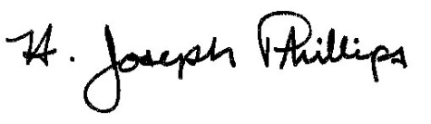 By:__ H. Joseph Phillips___________
Title: _Historic Officer____________
Date of Meeting: November 6, 2019

