RESOLUTION NO.__________

RE: CERTIFICATE OF APPROPRIATENESS UNDER THE
PROVISIONS OF THE ACT OF THE PENNSYLVANIA
LEGISLATURE 1961, JUNE 13, P.L. 282 (53
SECTION 8004) AND BETHLEHEM ORDINANCE NO.
3952 AS AMENDED.

The applicant proposes to install a new vinyl sign above the existing entryway at 462 Main St.

NOW, THEREFORE, BE IT RESOLVED by the Council of the City of Bethlehem that a Certificate of Appropriateness is hereby granted for the proposal.

Sponsored by: (s)

(s)

ADOPTED BY COUNCIL THIS DAY OF

(s)
President of Council

ATTEST:

(s)
City Clerk

HISTORICAL & ARCHITECTURAL REVIEW BOARD

It is proposed to install a new vinyl sign above the existing entryway at 462 Main St.
APPLICATION #6:
WALK-IN
Peter KIozicky
3580 North Drive
Bethlehem, PA 18015

OWNER:

__________________________________________________________________________

The Board upon motion by Beth Starbuck and seconded by Marsha Fritz adopted the proposal that City Council issue a Certificate of Appropriateness for the following:

1. The transom signage to be revised so the “Glass Bottled Soda Pop” sign should be in
the center panel.

2. The “Grandpa Joe’s” background color shall be revised to the same off-white color as
the transom signs.

3. Pinstriping shall be added to match the existing signage on the right side of the
marquis.

4. The motion was unanimous to approve.

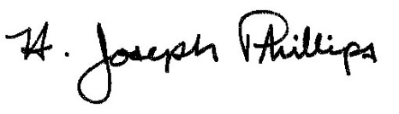 By:__ H. Joseph Phillips___________
Title: _Historic Officer____________
Date of Meeting: October 2, 2019

