RESOLUTION NO.__________

RE: CERTIFICATE OF APPROPRIATENESS UNDER THE
PROVISIONS OF THE ACT OF THE PENNSYLVANIA
LEGISLATURE 1961, JUNE 13, P.L. 282 (53
SECTION 8004) AND BETHLEHEM ORDINANCE NO.
3952 AS AMENDED.

The applicant proposes to install wayfinding signs at 33 W. Walnut St.

NOW, THEREFORE, BE IT RESOLVED by the Council of the City of Bethlehem that a Certificate of Appropriateness is hereby granted for the proposal.

Sponsored by: (s)

(s)

ADOPTED BY COUNCIL THIS DAY OF

(s)
President of Council

ATTEST:

(s)
City Clerk

HISTORICAL & ARCHITECTURAL REVIEW BOARD

It is proposed to install wayfinding signs at 33 W. Walnut St.
APPLICATION #6:

Bethlehem Parking Authority/Jeremy Alleshouse
85 W. North St.
Bethlehem, PA 18018

OWNER:

__________________________________________________________________________

The Board upon motion by Marsha Fritz and seconded by Diana Hodgson adopted the proposal that City Council issue a Certificate of Appropriateness for the following:

1. Public parking sign to be located under the crosswalk.

2. ‘P’ within a circle will be the universal symbol for parking and incorporated on all
signage.

3. A wall mounted sign shall be mounted directly above the garage entrance.

4. Refer to submitted packet for color selection.

5. The motion was unanimous to approve.

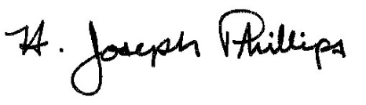 By:__ H. Joseph Phillips___________
Title: _Historic Officer____________
Date of Meeting: October 2, 2019

