RESOLUTION NO.__________

RE: CERTIFICATE OF APPROPRIATENESS UNDER THE
PROVISIONS OF THE ACT OF THE PENNSYLVANIA
LEGISLATURE 1961, JUNE 13, P.L. 282 (53
SECTION 8004) AND BETHLEHEM ORDINANCE NO.
3952 AS AMENDED.

The applicant proposes to install a fence in the rear yard at 14 E. Market St.

NOW, THEREFORE, BE IT RESOLVED by the Council of the City of Bethlehem that a Certificate of Appropriateness is hereby granted for the proposal.

Sponsored by: (s)

(s)

ADOPTED BY COUNCIL THIS DAY OF

(s)
President of Council

ATTEST:

(s)
City Clerk

HISTORICAL & ARCHITECTURAL REVIEW BOARD

It is proposed to install a fence in the rear yard at 14 E. Market St.
APPLICATION #4:

Glen Kershaw
14 E. Market St.
Bethlehem, PA 18018

OWNER:

__________________________________________________________________________

The Board upon motion by Diana Hodgson and seconded by Marsha Fritz adopted the proposal that City Council issue a Certificate of Appropriateness for the following:

1. The fence was previously approved. To have spear top, wrought iron with a
height of 4’-0”.

2. There will be 2 – 48” wide gates on each side of the property.

3. The fence will be black.

4. The motion was unanimous to approve.

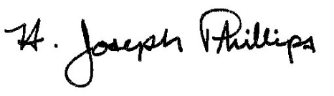 By:__ H. Joseph Phillips___________
Title: _Historic Officer____________
Date of Meeting: October 2, 2019

