RESOLUTION NO.__________

RE: CERTIFICATE OF APPROPRIATENESS UNDER THE
PROVISIONS OF THE ACT OF THE PENNSYLVANIA
LEGISLATURE 1961, JUNE 13, P.L. 282 (53
SECTION 8004) AND BETHLEHEM ORDINANCE NO.
3952 AS AMENDED.

The applicant proposes to install exterior lighting and a roof screen at
444 Main Street.

NOW, THEREFORE, BE IT RESOLVED by the Council of the City of Bethlehem that a Certificate of Appropriateness is hereby granted for the proposal.

Sponsored by: (s)

(s)

ADOPTED BY COUNCIL THIS DAY OF

(s)
President of Council

ATTEST:

(s)
City Clerk

HISTORICAL & ARCHITECTURAL REVIEW BOARD

It is proposed to install exterior lighting and a roof screen
at 444 Main St. (Moravian Book Store).
APPLICATION #3:

Moravian College
444 Main St.
Bethlehem, PA 18018

OWNER:

__________________________________________________________________________

The Board upon motion by Beth Starbuck and seconded by Diana Hodgson adopted the proposal that City Council issue a Certificate of Appropriateness for the following:

1. The exterior lighting to be gooseneck style fixtures pending review of newly
submitted fixture.

2. The fixture color is to be black.

3. To install a 40” high screen wall.

4. The wall is to be either medium or dark bronze anodized or Kynar painted finish.

5. The motion was unanimous to approve.

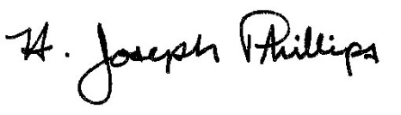 By:__ H. Joseph Phillips___________
Title: _Historic Officer____________
Date of Meeting: October 2, 2019

