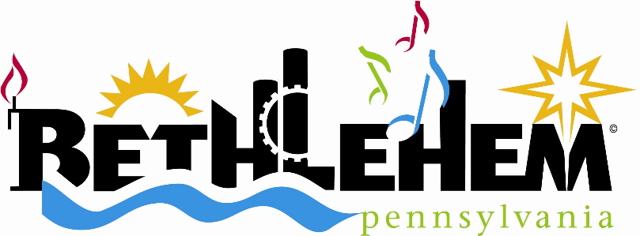

REQUEST FOR PROPOSALS
Professional Services for a Community Center Feasibility Study

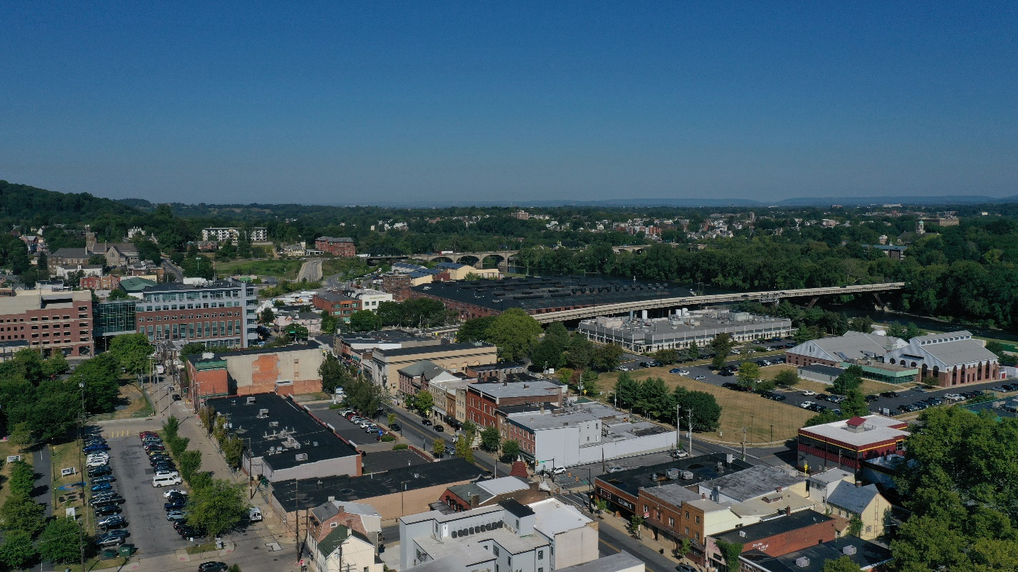

City of Bethlehem
Department of Community and Economic Development
10 East Church Street
Bethlehem, PA 18018

Direct questions to:
Sara Satullo, Deputy Director of Community Development
(610) 419-9003; ssatullo@bethlehem-pa.gov

REQUEST FOR PROPOSALS
COMMUNITY CENTER FEASIBILITY STUDY
The City of Bethlehem is requesting proposals from qualified and experienced firms and/or individuals to provide a comprehensive feasibility study for the creation, construction and operation of a community center in South Bethlehem.

SECTION 1: BACKGROUND
Bethlehem is a city of 76,000, located in northeast Pennsylvania. The Lehigh River bisects the city, creating its distinct north and South Side communities.

South Bethlehem, once home to the headquarters of Bethlehem Steel, is a historically working-class community undergoing a development boom that is placing pressure on its roughly 20,600 residents. The neighborhood’s biggest anchor institutions are Lehigh University, the nonprofit ArtsQuest and the Wind Creek Casino Resort. St. Luke’s University Health Network’s flagship campus sits just across the municipal line in Fountain Hill Borough.

About half of the city’s residents qualify as low and moderate income, with the greatest concentration in South Bethlehem.

The Southside is dotted with pocket parks, it boasts a skate plaza, pool and splash park as well as the South Bethlehem Greenway, a rail-to-trails park that serves as a public gathering space and a car-free transportation corridor. The community’s Boys & Girls Club closed in 2017, due to funding issues, and now only operates a facility in north Bethlehem. This has left a youth recreation void in the Southside despite these significant investments by the city and its partners in recent years.

The city’s recreation bureau operates five pools – four neighborhood and one regional – as well as a splash park in South Bethlehem. It offers free summer programming in parks across the city. But South Bethlehem lacks an indoor gathering and recreation space for youth and community groups.

Bethlehem seeks to create a community space for all ages, a place that is reflective of the City’s values as an inclusive and progressive community in its design, mission and usage. The City envisions a community hub where school kids pop in for pickup basketball games, fitness classes attract neighboring residents and the city’s health bureau holds health clinics. The facility should meet the needs of the immediate surrounding community, but also remain a welcoming space for any city resident.

The City wants the facility to be financially-accessible to all, but also self-sustaining. It envisions a community center in the same framework of the Bethlehem Area School District’s successful community schools model.

Viewing it as a once-in-a generation opportunity the City intends to invest some of its American Rescue Plan funds into a community center.

The City seeks a qualified firm or individual(s) to conduct a community center feasibility study, including analysis of a potential site(s). Responding firms are encouraged to be creative and innovative in evaluating any and all appropriate operational and financial models for the proposed facility.

The City intends to select a consultant which it deems best qualified in its judgment to provide applicable planning and technical services. The City will negotiate with the consultant deemed most qualified to determine the fee for such services. If the City is unable to negotiate a reasonable fee, the City may negotiate with the consultant deemed second best qualified or the City may issue another Request for Proposal.
Proposals are due electronically Friday, March 10, 2023, by 4:00 PM. The City shall provide a receipt email. Proposals shall be emailed to ssatullo@bethlehem-pa.gov.

SECTION 2: SCOPE OF WORK

Ongoing in all phases:
Through all phases of the study, the consultant team should conduct outreach to the Bethlehem community, including residents, community organizations, schools, major businesses and nonprofits. Public outreach and engagement should help determine and prioritize community needs and allow input on center models and design amenities under consideration.

Engagement efforts must prioritize diversity, equity, and inclusion and include multiple types of outreach, such as: small focus groups, neighborhood and virtual community meetings, online and in-person surveys, individual and group interviews. A minimum of 100 community stakeholders should be engaged throughout the study period. Engagement efforts must ensure that all residents of South Bethlehem have an equal voice in the community center planning and development.

South Bethlehem is 42% Hispanic and considered an area of minority concentration by the U.S. Census Bureau. Nearly 36% of South Bethlehem residents five years of age and older speak a language other than English at home, according to the Census. All engagement work should take these demographics into account. Spanish translation and bi-lingual materials should be included in all aspects of engagement.

Phase 1: Needs assessment
- Consultant shall conduct a needs and demand assessment, including an audit of existing City of Bethlehem and community organization’s recreation offerings.
- The needs assessment should include a demographic, market, and competitor analysis.
- The needs assessment should incorporate findings from community outreach and engagement as described above to help determine and prioritize needs and impacts of a new community center.

Phase 2: Site analysis
- The city has identified multiple potential sites for a community center. Consultant shall work with the City to assess the potential sites and will conduct a comprehensive feasibility analysis of at least one site.
- Analysis should consider neighborhood compatibility, positive attributes and challenges of the site and financial construction cost projections.
- Financial construction cost projects shall be based on a conceptual site design that fits the site layout, incorporates consultant’s proposed design amenities and considers the space required for different programming options.

Phase 3: Financial analysis
- Consultant shall provide a comprehensive financial analysis that includes the cost estimate for creating a new center, a cost estimate for site operations and revenue projections.
- Consultant shall recommend potential site operators and programming offerings as well as opportunities for lease/rental space for partner programming/services.
- The analysis should determine target demographics and membership terms/pricing; and identify possible subsidies.
- Consultant shall also identify and develop strategies for utilizing public and private funding streams and the creation of an endowment to fund and sustain the community center.

Phase 4: Final report with recommendations
Consultant will produce to City staff and the Mayor a draft feasibility study summarizing their findings and recommendations.
The feasibility study should clearly outline the consultants’ findings regarding the needs and demands of the community and the analysis of the proposed site(s). The feasibility should also set out clear and actionable recommendations for a site plan, programming, suitable operators, and a short- and long-term financial plan to sustain the facility.
Phase 5: Presentation of final report
The selected consultant will present the final report to the Mayor of Bethlehem, Bethlehem City Council and the community for consideration.
SECTION 3: PROPOSAL INFORMATION AND DATA REQUIRED OF EACH CONSULTANT

Proposals shall contain the following:

I. Qualifications, Capacity, Experience and References of the consultant
- A cover letter expressing the consultant’s interest in the project.
- A brief statement explaining why your firm is qualified to undertake this feasibility study, including examples of past relevant work.
- Demonstration of success on similar projects, including brief project descriptions and addresses for reference.
- A representative work sample similar to the type of work being requested.
- A list of individuals that will be committed to this project and their professional qualifications. The names and qualifications of any sub-consultants shall be included in this list.
- Provide up to five related references including agency name, contact, phone and email address.

II. Scope of Work Understanding and Description of Proposed Work
- A description of the general approach to be taken towards this project, an explanation of any variances in the scope of work outlined in this RFP and any insights gained through developing the proposal and previous work experience.
- A scope of work that includes detailed steps to be taken, including any products or deliverables resulting from each task.
- Include any ideas, comments, and or creative components that will enhance the delivery, strategies, policies and or overall final plan product.

III. Project Timeline and Budget
- Provide a project timeline for completion.
- A detailed budget of overall costs and a breakdown of the costs associated with each phase of the scope of work. Budget should include work hours per task, pay rate/assigned worker, total costs per task and total project cost.
- Budget should include all travel and soft costs, like engagement incentives.
- Provide a current rate schedule in case an additional task may be asked.

IV. Minority/Women-Owned/Section 3 Business
If the Consultant qualifies under any of the six business categories listed below, the Consultant shall provide such documentation.
A. Small business firm
B. Minority owned business firm
C. Women owned business firm
D. Section 3 business firm
E. Labor surplus area business firm
F. Bilingual team

V. Factors for Award
The City will evaluate each proposal and bring respondents in for interviews as necessary. Final scoring will take into account the strength of the proposals and interviews. The City will select the firm best qualified for the project and enter into a contract with them.

VI. Proposal Evaluation

The City will assign points for each segment of the proposal in accordance with the following weighted criteria and conduct interviews with finalists.

The consultants will be ranked from most qualified to least qualified. The firm deemed most qualified will receive the maximum points. Each succeeding consultant will receive a score in decreasing multiples of five points.

MAX POINTS | CRITERIA
30 | RELEVANT EXPERIENCE  - Demonstrated experience and knowledge in community center planning, design and financing.  - Experience working collaboratively with municipalities, community partners and underserved communities to develop successful public projects.  - Evidence of experience with community engagement, facilitating consensus among diverse stakeholders and strong communication abilities. Team must be bilingual and/or able to provide translation services.
25 | QUALIFICATIONS:  - Level of specific expertise, professional background and qualifications of team members and firm, including subcontractors.  - Strength of the design/project lead.  - Level of technological advancement and innovation.  - Knowledge and experience creating similar financially sustainable projects.  - Experienced design and management processes.
20 | PROJECT APPROACH:  - Understanding of the nature and extent of the services required.  - Awareness of potential challenges and possible solutions. Demonstrates innovative approach to solutions.  - Demonstrates an ability and innovative approaches to engage and develop stakeholder consensus.  - Responsive to City’s needs.  - A creative approach to the City’s proposed project, which demonstrates an understanding of the community.
10 | ORGANIZATION  - Available staff and specialized resources, if any.  - Cohesiveness of the project team.  - Proven cost and quality control procedures.  - Presentation, completeness, clarity, organization and responsiveness of proposals.
10 | RESPONSIVENESS  - Commitment and ability to perform on short notice and under time constraints.  - Capacity and flexibility to meet schedules, including any unexpected work.
5 | COST AND TIMELINE PROPOSAL:  - Submit a detailed cost proposal for each stage of the project as well as a lump sum cost. Proposal should include the costs per task and pay rate/assigned worker.  - Provide a project timeline.
100 | POSSIBLE RFP CRITERIA POINTS
30 | POSSIBLE BONUS POINTS  Five points per category possible with a maximum of 30 points through IV. Minority/Women-Owned/Section 3 Business
130 | TOTAL POSSIBLE POINTS

Distribution of the RFP:
This RFP is being distributed widely to local, regional, and national firms. This RFP is available by request; requests are to be emailed to Sara Satullo, Deputy Director of Community Development, City of Bethlehem Department of Community and Economic Development at ssatullo@bethlehem-pa.gov. Interested parties must register via email to ssatullo@bethlehem-pa.gov in order to receive updates and additional information via email.
Questions from Potential Respondents:
Questions from respondents regarding this RFP must be submitted in writing via email to Sara Satullo by Friday, Feb. 3, 2023, at 4:00 PM EST. Answers will be distributed via email to interested parties that have registered via email to ssatullo@bethlehem-pa.gov. Answers will be sent no later than Tuesday, Feb. 14, 2023.
Proposal Receipt Deadline:
All proposals are to be submitted electronically to Sara Satullo, Deputy Director Community Development, at ssatullo@bethlehem-pa.gov by 4:00 PM on Friday, March 10, 2023.
No proposals will be accepted after the time and date specified above, subject to any proposal receipt deadlines extended at the discretion of the City of Bethlehem.
Proposals are due electronically Friday, March 10, 2023 by 4:00 PM. The City shall provide a receipt email. Proposals shall be emailed to ssatullo@bethlehem-pa.gov.

