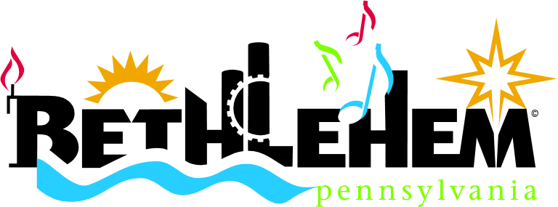
City of Bethlehem
Business Checklist
https://www.bethlehem-pa.gov/Community-Economic-Development/Economic-Development-Start-a-Business/Start-a-Business
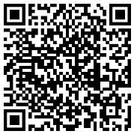

We’re glad that you are interested in locating or expanding your business in Bethlehem. This checklist will help make this process as simple as possible so you can get to the business of running your business!
Getting Started

The following items serve as the foundation for any business looking to operate within the City.
- I have outlined my business operations in a business plan or similar document. ☐Yes ☐Partly ☐No
- My business is legally formed and authorized to conduct business in Pennsylvania. ☐Yes ☐Partly ☐No
- I have identified potential locations in Bethlehem for my business. Need help? ☐Yes ☐Partly ☐No
Address #1:
Address #2:
Address #3:
- I have the financing in place necessary to facilitate this project. ☐Yes ☐Partly ☐No
Share the Details

With the groundwork of your business complete, it’s time to set up a meeting with the Department of Community & Economic Development (DCED). DCED encompasses site selection, planning and zoning, code enforcement, permitting, economic development, and health. This arrangement is essential to providing a streamlined experience for you and your business.

- Email starthere@bethlehem-pa.gov or call (610) 865-7085 to set up a meeting today.

Financial Resources

The City and community partners are committed to supporting small business & entrepreneurship. Please email starthere@bethlehem-pa.gov or call (610) 865-7085 to find out if you are eligible for any of the following programs:
- Bethlehem Small Business Loan Fund
- Facade Grant/Loan Programs
- Southside Bethlehem Keystone Innovation Zone
- US Small Business Administration Funding
Location Viability

When settling on a location for your business, it helps to locate in an area where it’s permitted! If permits and/or approvals are pending, you may want to condition any sale or lease upon their receipt.

- Email starthere@bethlehem-pa.gov or call (610) 865-7085 to discuss zoning with our Zoning Officer.

Permitting/Approvals

Now…it’s time for the homestretch! You are now at the point where it will become necessary to acquire the necessary permits for your business. The City has recently streamlined this process for your convenience and we’ll be happy to help you through this process. All permits and approvals will be managed by our Permit Coordinator. You can contact this person at any time through email starthere@bethlehem-pa.gov or calling (610) 865-7085.

- The first submission is the Commercial Certificate of Occupancy and supplemental documents listed below:

Commercial Certificate of Occupancy ☐Submitted
Building Permit ☐Submitted
Business Privilege License ☐Submitted
Health License (if applicable) ☐Submitted ☐N/A

- Your submission above will trigger additional permits as needed below and the corresponding departments will be notified that your permit will need to be reviewed:

Permit Checklist
Electrical ☐Submitted ☐Approved ☐N/A
Plumbing ☐Submitted ☐Approved ☐N/A
Mechanical ☐Submitted ☐Approved ☐N/A
Engineering ☐Submitted ☐Approved ☐N/A
Fire ☐Submitted ☐Approved ☐N/A
Traffic ☐Submitted ☐Approved ☐N/A
☐Submitted ☐Approved ☐N/A
☐Submitted ☐Approved ☐N/A
☐Submitted ☐Approved ☐N/A

- If you are planning on altering façade for your business or installing signs within one of the City’s Historic Districts, you will need to seek a Certificate of Appropriateness from the Historic District Commission.

Certificate of Appropriateness ☐Submitted ☐N/A
Historic District Design Guidelines & Map
Southside Design Guidelines, Signage Guidelines & Map

Final Steps

You’re almost across the finish line. Once you secure the items below, the City considers you officially open for business!
- Certificate of Occupancy (and Health License if Applicable) ☐Secured Permit #: Issue Date:
- Approved Business Privilege License ☐Secured License #: Issue Date:
- Certified Waste Hauler ☐Secured Hauler: Issue Date:

Congratulations on successfully opening your business! Email starthere@bethlehem-pa.gov or call (610) 865-7085 to set up a time for a ribbon cutting.
Final Steps!

This business checklist is intended to serve as a guide for individuals interested in opening a business in the City of Bethlehem.

