RESOLUTION NO.__________

RE: CERTIFICATE OF APPROPRIATENESS UNDER THE
PROVISIONS OF THE ACT OF THE PENNSYLVANIA
LEGISLATURE 1961, JUNE 13, P.L. 282 (53
SECTION 8004) AND BETHLEHEM ORDINANCE NO.
3952 AS AMENDED.

The applicant proposes to replace a leaking roof at 215 East Church St.

NOW, THEREFORE, BE IT RESOLVED by the Council of the City of Bethlehem that a Certificate of Appropriateness is hereby granted for the proposal.

Sponsored by: (s)

(s)

ADOPTED BY COUNCIL THIS DAY OF

(s)
President of Council

ATTEST:

(s)
City Clerk

HISTORICAL & ARCHITECTURAL REVIEW BOARD

The applicant proposes to replace a leaking roof at 215 East
Church St.

APPLICATION #4:
WALK-IN

William S. Scudder, Jr.
215 E. Church St.
Bethlehem, PA 18018

OWNER:

__________________________________________________________________________

The Board upon motion by Phil Roeder and seconded by Beth Starbuck adopted the proposal that City Council issue a Certificate of Appropriateness for the following:

1. The slate porch roof will be replace in-kind.

2. The slate upper roof will be replaced with GAF Slateline fiberglass shingles in
Antique Slate color.

3. The valleys will be open copper.

4. Metal drip edge or metal trim will be in a color to match or in copper.

5. Flashings at the intersection of vertical elements to be copper.

6. Existing slate on the vertical side of the dormer to be replaced with GAF Slateline
fiberglass shingles.

7. Gutters to be aluminum half round in a color to match the trim. Downspouts will be
aluminum corrugated or round in a color to also match the trim.

8. The motion was unanimously approved.

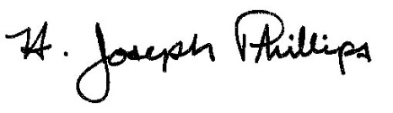 By:__ H. Joseph Phillips___________
Title: _Historic Officer____________
Date of Meeting: August 7, 2019

