RESOLUTION NO.__________

RE: CERTIFICATE OF APPROPRIATENESS UNDER THE
PROVISIONS OF THE ACT OF THE PENNSYLVANIA
LEGISLATURE 1961, JUNE 13, P.L. 282 (53
SECTION 8004) AND BETHLEHEM ORDINANCE NO.
3952 AS AMENDED.

The applicant proposes to install a fence at 14 E.Market St.

NOW, THEREFORE, BE IT RESOLVED by the Council of the City of Bethlehem that a Certificate of Appropriateness is hereby granted for the proposal.

Sponsored by: (s)

(s)

ADOPTED BY COUNCIL THIS DAY OF

(s)
President of Council

ATTEST:

(s)
City Clerk

HISTORICAL & ARCHITECTURAL REVIEW BOARD

The applicant proposes to install a fence at 14 E. Market St.

APPLICATION #2:

Glen & Whitney Kershaw
1646 Highland Avenue
Glendale, CA 91202

OWNER:

__________________________________________________________________________

The Board upon motion by Phil Roeder and seconded by Beth Starbuck adopted the proposal that City Council issue a Certificate of Appropriateness for the following:

1. Install a 54” high black powder coated fence.

2. Fence to have two 36” wide gates.

3. The motion was unanimously approved.

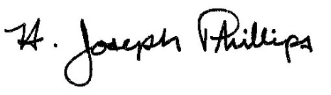 By:__ H. Joseph Phillips___________
Title: _Historic Officer____________
Date of Meeting: August 7, 2019

