RESOLUTION NO.__________

RE: CERTIFICATE OF APPROPRIATENESS UNDER THE
PROVISIONS OF THE ACT OF THE PENNSYLVANIA
LEGISLATURE 1961, JUNE 13, P.L. 282 (53
SECTION 8004) AND BETHLEHEM ORDINANCE NO.
3952 AS AMENDED.

The applicant proposes to install three Gooseneck lighting fixtures at 445 High Street to illuminate Milton Street.

NOW, THEREFORE, BE IT RESOLVED by the Council of the City of Bethlehem that a Certificate of Appropriateness is hereby granted for the proposal.

Sponsored by: (s)

(s)

ADOPTED BY COUNCIL THIS DAY OF

(s)
President of Council

ATTEST:

(s)
City Clerk

HISTORICAL & ARCHITECTURAL REVIEW BOARD

The applicant proposes to install three Gooseneck lighting fixtures at 445 High Street to illuminate Milton Street.

APPLICATION #1:

Kyle Lebouitz
445 High Street
Bethlehem, PA 18018

OWNER:

__________________________________________________________________________

The Board upon motion by Diana Hodgson and seconded by Derrick Clark adopted the proposal that City Council issue a Certificate of Appropriateness for the following:

1. The temperature of the LED lighting will be between 2700 and 3000 Kelvin and
installed approximately 20 ft. on center from each other.

2. The lighting fixtures color will be dark green as per the sample fixture provided.

3. Cabling will run primarily horizontally in line with the mortar joint and match
the mortar joint color as closely as possible.

4. Fasteners for the cabling will also match the color of the cabling as closely as
possible.

5. The motion was unanimously approved.

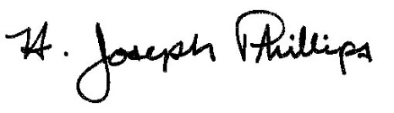 By:__ H. Joseph Phillips___________
Title: _Historic Officer____________
Date of Meeting: August 7, 2019

