RESOLUTION NO.__________

RE: CERTIFICATE OF APPROPRIATENESS UNDER THE
PROVISIONS OF THE ACT OF THE PENNSYLVANIA
LEGISLATURE 1961, JUNE 13, P.L. 282 (53
SECTION 8004) AND BETHLEHEM ORDINANCE NO.
3952 AS AMENDED.

WHEREAS, it is proposed to secure a COA to demolish the rear apartment, construct a new rear deck, replace windows, shutters and doors and make various exterior alterations as necessary at 601 East Fourth Street.

NOW, THEREFORE, BE IT RESOLVED by the Council of the City of Bethlehem that a Certificate of Appropriateness is hereby granted for the proposal.

Sponsored by: (s)

(s)

ADOPTED BY COUNCIL THIS DAY OF

(s)
President of Council

ATTEST:

(s)
City Clerk

HISTORIC CONSERVATION COMMISSION

CASE #697 -- It is proposed to demolish the rear apartment, construct a new rear deck, replace windows, shutters and doors and make various exterior alterations as necessary at 601 East Fourth Street.

OWNER / APPLICANT: 601 East Fourth Street, LLC / Bruce Campbell

The Commission upon motion by Mr. Roeder and seconded by Mr. Hudak adopted the proposal that City Council issue a Certificate of Appropriateness for the proposed work as presented (with modifications) described herein:

- The proposal to demolish the rear apartment, construct a new rear deck, replace windows, shutters and doors and make various exterior alterations as necessary was presented by Bruce Campbell.
- Approved improvements include: Jeld-Wen replacement windows in 1-over-1 configuration (except for large-format shop window with fixed decorative transom) with aluminum exterior cladding in bronze color; exterior storm windows to include full screen detail, with meeting rail to match meeting rail of correlating window; repair/replace in-kind existing window trim, painted in lighter contrasting color
- Based upon verbal approval to demolish rear apartment structure and masonry privacy wall, the Applicant agreed to return to HCC with measured drawings along with specifics concerning dimensions, materials, colors, etc. of various design elements within a subsequent COA Application.
- The motion for the proposed work was unanimously approved.

JBL: jbl
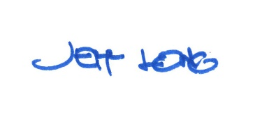

By:

Date of Meeting: July 15, 2019

