RESOLUTION NO.__________

RE: CERTIFICATE OF APPROPRIATENESS UNDER THE
PROVISIONS OF THE ACT OF THE PENNSYLVANIA
LEGISLATURE 1961, JUNE 13, P.L. 282 (53
SECTION 8004) AND BETHLEHEM ORDINANCE NO.
3952 AS AMENDED.

The applicant proposes to place a 2’ x 3’ sign in the front left garden area of the property at 61 West Market St.

NOW, THEREFORE, BE IT RESOLVED by the Council of the City of Bethlehem that a Certificate of Appropriateness is hereby granted for the proposal.

Sponsored by: (s)

(s)

ADOPTED BY COUNCIL THIS DAY OF

(s)
President of Council

ATTEST:

(s)
City Clerk

HISTORICAL & ARCHITECTURAL REVIEW BOARD

The applicant proposes to place a 2’ x 3’ sign in the front left garden area of the property at 61 West Market St.

APPLICATION #5:

Moravian Union of the King’s Daughters & Sons, Inc.
Sean O’Keefe
61 W. Market St.
Bethlehem, PA 18018

OWNER:

__________________________________________________________________________

The Board upon motion by Connie Glagola and seconded by Marsha Fritz adopted the proposal that City Council issue a Certificate of Appropriateness for the following:

1. As previously submitted, the sign design will be the same including the IHN logo,
beige background, purple letters outlined in black and black and tan border.

2. The wording of the text will be revised to read “MORAVIAN KING’S DAUGHTERS
AND SONS HOME”.

3. The mounting post will be painted black.

4. The motion was unanimously approved.

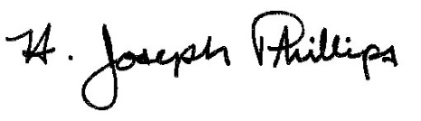 By:__ H. Joseph Phillips___________
Title: _Historic Officer____________
Date of Meeting: July 10, 2019

