RESOLUTION NO.__________

RE: CERTIFICATE OF APPROPRIATENESS UNDER THE
PROVISIONS OF THE ACT OF THE PENNSYLVANIA
LEGISLATURE 1961, JUNE 13, P.L. 282 (53
SECTION 8004) AND BETHLEHEM ORDINANCE NO.
3952 AS AMENDED.

The applicant proposes to remove old awning sign and replace with plexiglass and new signage at 81 West Broad St.

NOW, THEREFORE, BE IT RESOLVED by the Council of the City of Bethlehem that a Certificate of Appropriateness is hereby granted for the proposal.

Sponsored by: (s)

(s)

ADOPTED BY COUNCIL THIS DAY OF

(s)
President of Council

ATTEST:

(s)
City Clerk

HISTORICAL & ARCHITECTURAL REVIEW BOARD

The applicant proposes to remove old awning sign and replace with plexiglass and add new signage at 81 West Broad St.

APPLICATION #3:

Domenic Villani
530 Wafford Lane
Bethlehem, PA 18018

OWNER:

__________________________________________________________________________

The Board upon motion by Phil Roeder and seconded by Marsha Fritz adopted the proposal that City Council issue a Certificate of Appropriateness for the following:

1. The new sign will be wood or a medium density overlay board sign, 2.25’ x 11’ in
size located in the area of the existing transom above the existing triple window.

2. The sign will be mounted with hidden fasteners.

3. The sign background color will be Colonial Revival Grey.

4. There will be a 3/8” wide pinstripe located ½” from the perimeter edge of the sign
with serif letters and the color will be Rookwood Red.

5. The motion was unanimously approved.

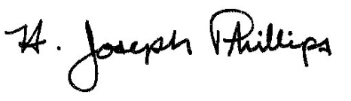 By:__ H. Joseph Phillips___________
Title: _Historic Officer____________
Date of Meeting: July 10, 2019

