RESOLUTION NO.__________

RE: CERTIFICATE OF APPROPRIATENESS UNDER THE
PROVISIONS OF THE ACT OF THE PENNSYLVANIA
LEGISLATURE 1961, JUNE 13, P.L. 282 (53
SECTION 8004) AND BETHLEHEM ORDINANCE NO.
3952 AS AMENDED.

WHEREAS, it is proposed to secure a COA to remove all aluminum siding, exposing and restoring brick and wood trim and to demolish the rear apartment building at 601 East Fourth Street.

NOW, THEREFORE, BE IT RESOLVED by the Council of the City of Bethlehem that a Certificate of Appropriateness is hereby granted for the proposal.

Sponsored by: (s)

(s)

ADOPTED BY COUNCIL THIS DAY OF

(s)
President of Council

ATTEST:

(s)
City Clerk

HISTORIC CONSERVATION COMMISSION

CASE #696 -- It is proposed to remove all aluminum siding, exposing and restoring brick and wood trim and to demolish the rear apartment building at 601 East Fourth Street.

OWNER / APPLICANT: Bruce Campbell / Bruce Campbell

The Commission upon motion by Mr. Cornish and seconded by Ms. Starbuck adopted the proposal that City Council issue a Certificate of Appropriateness for the proposed work as presented (with modifications) described herein:

- The proposal to remove all aluminum siding, exposing and restoring the brick and wood trim in-kind and to demolish the rear apartment building was presented by Bruce Campbell.
- The proposal to remove all aluminum siding, exposing and restoring brick and wood trim in-kind was approved, as submitted; cleaning of revealed brick using mild detergents (no harsh chemicals) and low-pressure wash is allowed.
- Commission consideration of the proposal to demolish the rear garage apartment is contingent upon the Applicant’s ability to provide to-scale drawings of the design for a new rear patio/deck as replacement for the demolished structure.
- The motion for the proposed work was unanimously approved.

JBL: jbl
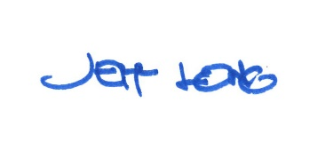

By:

Date of Meeting: June 17, 2019 Title: Historic Officer

