RESOLUTION NO.__________

RE: CERTIFICATE OF APPROPRIATENESS UNDER THE
PROVISIONS OF THE ACT OF THE PENNSYLVANIA
LEGISLATURE 1961, JUNE 13, P.L. 282 (53
SECTION 8004) AND BETHLEHEM ORDINANCE NO.
3952 AS AMENDED.

WHEREAS, it is proposed to secure a COA to install antennas, cables and cabinets at 4 East Fourth Street.

NOW, THEREFORE, BE IT RESOLVED by the Council of the City of Bethlehem that a Certificate of Appropriateness is hereby granted for the proposal.

Sponsored by: (s)

(s)

ADOPTED BY COUNCIL THIS DAY OF

(s)
President of Council

ATTEST:

(s)
City Clerk

HISTORIC CONSERVATION COMMISSION

CASE #693 -- It is proposed to install antennas, cables and cabinets at 4 East Fourth Street.

OWNER / APPLICANT: Bethlehem Developers of PA / T-Mobile Northeast, LLC

The Commission upon motion by Mr. Loush and seconded by Mr. Hudak adopted the proposal that City Council issue a Certificate of Appropriateness for the proposed work as presented (with modifications) described herein:

- The proposal to install antennas, cables and cabinets was presented by Michael Fahey and Dana Freshcoln.
- Approved improvements include:
  - replace three existing panel antennas; replacement antennas measure 58 inches tall and are to be installed on existing mounts at same centerline as current antennas
  - install three new panel antennas; size of new antennas to match size of replacement antennas
  - install three new Remote Radio Units; new RRUs measure 13 inches x 14 inches x 5 feet 4 inches and are to be installed behind existing and new antennas; RRUs are pre-finished in black color
  - replace two existing cabinets; new units are smaller than existing cabinets
- The Applicant agreed to paint all paintable equipment in a dark brown color to match the façade of the mechanical penthouse. The Applicant also agreed to paint any new conduit lines to match the adjacent brick façade in a medium brown color, if ultimately needed.
- The motion for the proposed work was unanimously approved.

JBL: jbl
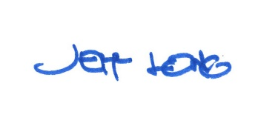

By:

Date of Meeting: June 17, 2019 Title: Historic Officer

