RESOLUTION NO.__________

RE: CERTIFICATE OF APPROPRIATENESS UNDER THE
PROVISIONS OF THE ACT OF THE PENNSYLVANIA
LEGISLATURE 1961, JUNE 13, P.L. 282 (53
SECTION 8004) AND BETHLEHEM ORDINANCE NO.
3952 AS AMENDED.

The applicant proposes to remove and replace shutters and hardware at
54 E. Wall St.

NOW, THEREFORE, BE IT RESOLVED by the Council of the City of Bethlehem that a Certificate of Appropriateness is hereby granted for the proposal.

Sponsored by: (s)

(s)

ADOPTED BY COUNCIL THIS DAY OF

(s)
President of Council

ATTEST:

(s)
City Clerk

HISTORICAL & ARCHITECTURAL REVIEW BOARD

The applicant proposes to remove and replace shutters and hardware at 54 E. Wall St.

APPLICATION #7:

Robert C. Marshall
54 E. Wall St.
Bethlehem, PA 18018

OWNER:

__________________________________________________________________________

The Board upon motion by Phil Roeder and seconded by Marsha Fritz adopted the proposal that City Council issue a Certificate of Appropriateness for the following:

1. New shutter to be replaced in-kind to match style, color etc. of existing shutters.

2. Existing shutter hardware will be reused where possible. Hardware that need
replacing will be done so in-kind.

3. The motion was unanimously approved.

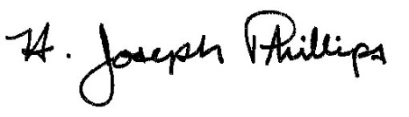 By:__H. Joseph Phillips___________

Title: _Historic Officer____________

Date of Meeting: June 5, 2019

