RESOLUTION NO.__________

RE: CERTIFICATE OF APPROPRIATENESS UNDER THE
PROVISIONS OF THE ACT OF THE PENNSYLVANIA
LEGISLATURE 1961, JUNE 13, P.L. 282 (53
SECTION 8004) AND BETHLEHEM ORDINANCE NO.
3952 AS AMENDED.

The applicant proposes to remove and replace exterior windows and casing at 54 E. Wall St.

NOW, THEREFORE, BE IT RESOLVED by the Council of the City of Bethlehem that a Certificate of Appropriateness is hereby granted for the proposal.

Sponsored by: (s)

(s)

ADOPTED BY COUNCIL THIS DAY OF

(s)
President of Council

ATTEST:

(s)
City Clerk

HISTORICAL & ARCHITECTURAL REVIEW BOARD

The applicant proposes to remove and replace exterior windows and casing at 54 E. Wall St.

APPLICATION #6:

Robert C. Marshall
54 E. Wall St.
Bethlehem, PA 18018

OWNER:

__________________________________________________________________________

The Board upon motion by Marsha Fritz and seconded by Diana Hodgson adopted the proposal that City Council issue a Certificate of Appropriateness for the following:

1. The replacement windows will be wood and painted to match existing windows.

2. Existing casing will be retained where possible. If necessary to replace, will do so
in-kind.

3. Windows to be Andersen Woodwright series 400.

4. All anchors and attachments to be located in the mortar joints not in the body of the
brick.

5. The motion was unanimously approved.

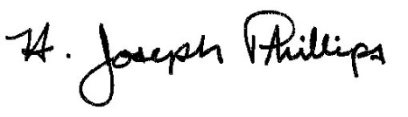 By:__H. Joseph Phillips___________

Title: _Historic Officer____________

Date of Meeting: June 5, 2019

