RESOLUTION NO.__________

RE: CERTIFICATE OF APPROPRIATENESS UNDER THE
PROVISIONS OF THE ACT OF THE PENNSYLVANIA
LEGISLATURE 1961, JUNE 13, P.L. 282 (53
SECTION 8004) AND BETHLEHEM ORDINANCE NO.
3952 AS AMENDED.

The applicant proposes to install wireless antennas, cabinets and generator to the existing site at 437 Main St.

NOW, THEREFORE, BE IT RESOLVED by the Council of the City of Bethlehem that a Certificate of Appropriateness is hereby granted for the proposal.

Sponsored by: (s)

(s)

ADOPTED BY COUNCIL THIS DAY OF

(s)
President of Council

ATTEST:

(s)
City Clerk

HISTORICAL & ARCHITECTURAL REVIEW BOARD

The applicant proposes to install wireless antennas, cabinets and generator to the existing site at 437 Main St.

APPLICATION #5:

Christmas City Hotel LLC
437 Main St.
Bethlehem, PA 18018

OWNER:

__________________________________________________________________________

The Board upon motion by Derrick Clark and seconded by Marsha Fritz adopted the proposal that City Council issue a Certificate of Appropriateness for the following:

1. The larger TV size antenna to be painted flat black. (applicant to confirm this is
possible thru the Historic Officer)

2. Color of the proposed four smaller antennas to match existing color of antenna’s.
(applicant to confirm this is possible thru the Historic Officer)

3. Applicant to research, select and use anchors, fasteners and attachments
appropriate for location in the mortar joint. To be approved by the Historic Officer.

4. All anchors and attachments to be located in the mortar joints not in the body of the
brick.

5. Items mounted to the building shall be painted in a color to match the surface that
they are mounted to.

6. The motion was unanimously approved.

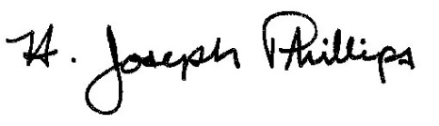 By:__H. Joseph Phillips___________

Title: _Historic Officer____________

Date of Meeting: June 5, 2019

