RESOLUTION NO.__________

RE: CERTIFICATE OF APPROPRIATENESS UNDER THE
PROVISIONS OF THE ACT OF THE PENNSYLVANIA
LEGISLATURE 1961, JUNE 13, P.L. 282 (53
SECTION 8004) AND BETHLEHEM ORDINANCE NO.
3952 AS AMENDED.

The applicant proposes to install vinyl decal signs on the 1st floor windows at
79 W. Market St.

NOW, THEREFORE, BE IT RESOLVED by the Council of the City of Bethlehem that a Certificate of Appropriateness is hereby granted for the proposal.

Sponsored by: (s)

(s)

ADOPTED BY COUNCIL THIS DAY OF

(s)
President of Council

ATTEST:

(s)
City Clerk

HISTORICAL & ARCHITECTURAL REVIEW BOARD

The applicant proposes to install vinyl decal signs on the 1st floor windows at 79 W. Market St.

APPLICATION #3:

Rudy Amelio
1348 Hamilton Street
Allentown, PA 18102

OWNER:

__________________________________________________________________________

The Board upon motion by Connie Postupack and seconded by Connie Glagola adopted the proposal that City Council issue a Certificate of Appropriateness for the following:

1. Vinyl decal sign installed with company logo.

2. The logo and letters will be outlined in white.

3. The motion was unanimously approved.

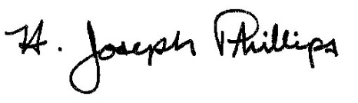 By:__H. Joseph Phillips___________

Title: _Historic Officer____________

Date of Meeting: June 5, 2019

