RESOLUTION NO.__________

RE: CERTIFICATE OF APPROPRIATENESS UNDER THE
PROVISIONS OF THE ACT OF THE PENNSYLVANIA
LEGISLATURE 1961, JUNE 13, P.L. 282 (53
SECTION 8004) AND BETHLEHEM ORDINANCE NO.
3952 AS AMENDED.

The applicant proposes to rebuild the front porch and stairs and remove and replace a concrete walkway and drainage swale at 253 E. Church St.

NOW, THEREFORE, BE IT RESOLVED by the Council of the City of Bethlehem that a Certificate of Appropriateness is hereby granted for the proposal.

Sponsored by: (s)

(s)

ADOPTED BY COUNCIL THIS DAY OF

(s)
President of Council

ATTEST:

(s)
City Clerk

HISTORICAL & ARCHITECTURAL REVIEW BOARD

The applicant proposes to rebuild the front porch and stairs and remove and replace a concrete walkway and drainage swale at 253 E. Church St.

APPLICATION #2:

OWNER:
Cheryl Dougan & Anthony Vicscardi
253 East Church St.
Bethlehem, PA 18018

__________________________________________________________________________

The Board upon motion by Derrick Clark and seconded by Marsha Fritz adopted the proposal that City Council issue a Certificate of Appropriateness for the following:

1. The existing design profiles and colors to be matched in-kind.

2. Applicant to make every effort to replace the deteriorated bottom section of the
posts with Aeratis composite material.

3. If replacing posts in their entirety, all to match composite in-kind.

4. Porch floor, stair treads and stair risers to be manufactured using the Aeratis
composite material to match samples presented at meeting.

5. The motion was unanimously approved.

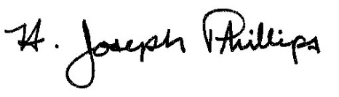 By:__H. Joseph Phillips___________

Title: _Historic Officer____________

Date of Meeting: June 5, 2019

