RESOLUTION NO.__________

RE: CERTIFICATE OF APPROPRIATENESS UNDER THE
PROVISIONS OF THE ACT OF THE PENNSYLVANIA
LEGISLATURE 1961, JUNE 13, P.L. 282 (53
SECTION 8004) AND BETHLEHEM ORDINANCE NO.
3952 AS AMENDED.

The applicant proposes to replace the windows at 403 Center St.

NOW, THEREFORE, BE IT RESOLVED by the Council of the City of Bethlehem that a Certificate of Appropriateness is hereby granted for the proposal.

Sponsored by: (s)

(s)

ADOPTED BY COUNCIL THIS DAY OF

(s)
President of Council

ATTEST:

(s)
City Clerk

HISTORICAL & ARCHITECTURAL REVIEW BOARD

The applicant proposes to replace the windows at 403 Center St.

APPLICATION #1:

James & Eileen Serratelli
403 Center St.
Bethlehem, PA 18018

OWNER:

__________________________________________________________________________

The Board upon motion by Diana Hodgson and seconded by Connie Postupack adopted the proposal that City Council issue a Certificate of Appropriateness for the following:

1. To replace 5 south facing windows to be Marvin Next Generation Ultimate double
hung windows constructed of Douglas Fir.

2. The two existing archtop windows will be replaced with rectangular 6 over 6
windows.

3. Three windows in the bay will be replaced with rectangular 4 over 4 windows.

4. All window sizes, styles, rails, muntins, casings, etc. will be matched in-kind.

5. The heavy or thick original window sills will be retained and repaired to the
greatest extent possible.

6. All wood window and trim surfaces will be painted with Sherwin Williams
Emerald Urethane Trim Enamel in their Smart White color.

7. The motion was unanimously approved.

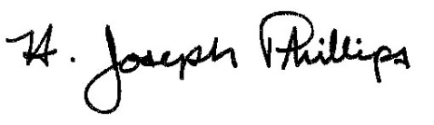 By:__H. Joseph Phillips___________
Title: _Historic Officer____________
Date of Meeting: June 5, 2019

