RESOLUTION NO.__________

RE: CERTIFICATE OF APPROPRIATENESS UNDER THE
PROVISIONS OF THE ACT OF THE PENNSYLVANIA
LEGISLATURE 1961, JUNE 13, P.L. 282 (53
SECTION 8004) AND BETHLEHEM ORDINANCE NO.
3952 AS AMENDED.

The applicant proposes to replace the low sloped shingled porch roof with a flat seam metal roof at 450 High St.

NOW, THEREFORE, BE IT RESOLVED by the Council of the City of Bethlehem that a Certificate of Appropriateness is hereby granted for the proposal.

Sponsored by: (s)

(s)

ADOPTED BY COUNCIL THIS DAY OF

(s)
President of Council

ATTEST:

(s)
City Clerk

HISTORICAL & ARCHITECTURAL REVIEW BOARD

The applicant proposes to replace the low sloped shingled porch roof with a flat seam metal roof at 450 High St.

APPLICATION #4B:

Scott & Jennifer Hawk
450 High St.
Bethlehem, PA 18018

OWNER:

__________________________________________________________________________

The Board upon motion by Phil Roeder and seconded by Diana Hodgson adopted the proposal that City Council issue a Certificate of Appropriateness for the following:

1. Metal roof shall match the color of the main roof as closely as possible.

2. The applicant will provide a range of color samples to the Historic Officer for review,
selection and approval for the new porch roof gutters.

3. If needed, porch ceiling will be replaced with in-kind materials, profiles, etc. to
match existing.

4. The motion was unanimously approved.

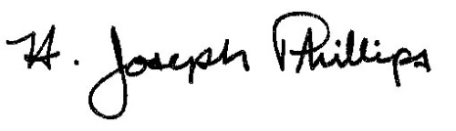 By:__H. Joseph Phillips___________

Title: _Historic Officer____________

Date of Meeting: June 5, 2019

