RESOLUTION NO. 2019-

RE: CERTIFICATE OF APPROPRIATENESS UNDER THE
PROVISIONS OF THE ACT OF THE PENNSYLVANIA
LEGISLATURE 1961, JUNE 13, P.L. 282 (53
SECTION 8004) AND BETHLEHEM ORDINANCE NO.
3952 AS AMENDED.

The applicant proposes to remove existing signs and replace with new signage at
512 Main St.

NOW, THEREFORE, BE IT RESOLVED by the Council of the City of Bethlehem that a Certificate of Appropriateness is hereby granted for the proposal.

Sponsored by: (s)

(s)

ADOPTED BY COUNCIL THIS DAY OF

(s)
President of Council

ATTEST:

(s)
City Clerk

HISTORICAL & ARCHITECTURAL REVIEW BOARD

The applicant proposes to remove existing signs and replace with new signage at 512 Main St.

APPLICATION #5:

JAD Investors
1778 Arden Lane
Bethlehem, PA 18018

OWNER:

__________________________________________________________________________

The Board upon motion by Connie Glagola and seconded by Marsha Fritz adopted the proposal that City Council issue a Certificate of Appropriateness for the following:

1. Replace all current window vinyl graphics, hanging scroll sign and
Architectural letters.

2. All lettering will be serif in colors presented.

3. The motion was unanimously approved.

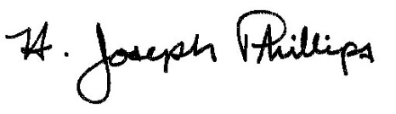 By:__H. Joseph Phillips___________

Title: _Historic Officer____________

Date of Meeting: May 1, 2019

