RESOLUTION NO. 2019-

RE: CERTIFICATE OF APPROPRIATENESS UNDER THE
PROVISIONS OF THE ACT OF THE PENNSYLVANIA
LEGISLATURE 1961, JUNE 13, P.L. 282 (53
SECTION 8004) AND BETHLEHEM ORDINANCE NO.
3952 AS AMENDED.

The applicant proposes to replace a wood fence with a brick wall at
131 E. Church St.

.
NOW, THEREFORE, BE IT RESOLVED by the Council of the City of Bethlehem that a Certificate of Appropriateness is hereby granted for the proposal.

Sponsored by: (s)

(s)

ADOPTED BY COUNCIL THIS DAY OF

(s)
President of Council

ATTEST:

(s)
City Clerk

HISTORICAL & ARCHITECTURAL REVIEW BOARD

The applicant proposes to replace a wood fence with a brick wall at
131 E. Church St.

APPLICATION #4:

River Properties
131 E. Church St.
Bethlehem, PA 18018

OWNER:

__________________________________________________________________________

The Board upon motion by Marsha Fritz and seconded by Diana Hodgson adopted the proposal that City Council issue a Certificate of Appropriateness for the following:

1. Remove existing 6 ft. high wood fence and 6 ft. high brick wall.

2. Brick wall with expressed piers to run parallel to Wesley St. and along the
neighboring property to the east.

3. The curved segmented aluminum fence with expressed brick piers will be
adjacent to the driveway.

4. Brick piers to be capped with precast concrete caps.

5. There will also be two gates as shown on drawing.

6. The motion was unanimously approved.

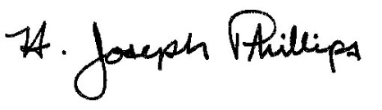 By:__H. Joseph Phillips___________

Title: _Historic Officer____________

Date of Meeting: May 1, 2019

