RESOLUTION NO. 2019-

RE: CERTIFICATE OF APPROPRIATENESS UNDER THE
PROVISIONS OF THE ACT OF THE PENNSYLVANIA
LEGISLATURE 1961, JUNE 13, P.L. 282 (53
SECTION 8004) AND BETHLEHEM ORDINANCE NO.
3952 AS AMENDED.

The applicant proposes to change the paint color of the wood trim elements at
8 W. Church St.

NOW, THEREFORE, BE IT RESOLVED by the Council of the City of Bethlehem that a Certificate of Appropriateness is hereby granted for the proposal.

Sponsored by: (s)

(s)

ADOPTED BY COUNCIL THIS DAY OF

(s)
President of Council

ATTEST:

(s)
City Clerk

HISTORICAL & ARCHITECTURAL REVIEW BOARD

The applicant proposes to change the paint color of the wood trim elements at 8 W. Church St.

APPLICATION #1:
Walk-In

Andrew Grason
8 W. Church St.
Bethlehem, PA 18018

OWNER:

__________________________________________________________________________

The Board upon motion by Marsha Fritz and seconded by Connie Glagola adopted the proposal that City Council issue a Certificate of Appropriateness for the following:

1. Paint color for wood soffit, eave, window sash, cornice and all trim elements will
be changed to match Marvin Window Company’s color “Cashmere”.

2. The motion was unanimously approved.

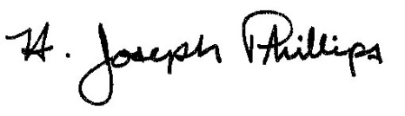 By:__H. Joseph Phillips___________

Title: _Historic Officer____________

Date of Meeting: May 1, 2019

