RESOLUTION NO. 2019-

RE: CERTIFICATE OF APPROPRIATENESS UNDER THE
PROVISIONS OF THE ACT OF THE PENNSYLVANIA
LEGISLATURE 1961, JUNE 13, P.L. 282 (53
SECTION 8004) AND BETHLEHEM ORDINANCE NO.
3952 AS AMENDED.

WHEREAS, it is proposed to secure a COA to install a 50’ x 11’ awning over the north terrace at 306 South New Street (Zest Bar & Grille).

NOW, THEREFORE, BE IT RESOLVED by the Council of the City of Bethlehem that a Certificate of Appropriateness is hereby granted for the proposal.

Sponsored by: (s)

(s)

ADOPTED BY COUNCIL THIS DAY OF

(s)
President of Council

ATTEST:

(s)
City Clerk

HISTORIC CONSERVATION COMMISSION

CASE #690 -- It is proposed to install a 50’ x 11’ awning over the north terrace at 306 South New Street (Zest Bar & Grille).

OWNER / APPLICANT: Greenway 1, Inc. / Grille 3502, LLC

The Commission upon motion by Mr. Roeder and seconded by Mr. Loush adopted the proposal that City Council issue a Certificate of Appropriateness for the proposed work as presented (with modifications) described herein:

- The proposal to install a 50’ x 11’ awning over the north terrace was presented by James Eck and John Trapani.
- Details of approved new awning at 6th floor terrace along north façade only (adjacent to recently enclosed portion) include:
  - Firesist canvas awning in color Fog (No. 82024) to match existing metal panels; color is solid with no applied designs or advertisements
  - details of mounting hardware and awning armature to be submitted for review by Historic Office via City of Bethlehem prior to construction
  - seasonal use of awning limited to May 1 through October 15
  - pitch of awning is max. 1.5/12
  - awning extends entire remaining length of terrace but sets back from terrace parapet min. 12 inches
  - front flap valance is max. 6 inches high and end gable is enclosed with awning fabric
- The motion for the proposed work was approved 5:1, with Mr. Evans voting against the proposal.

JBL: jbl
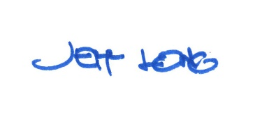

By:

Date of Meeting: April 15, 2019 Title: Historic Officer

