RESOLUTION NO.__________

RE: CERTIFICATE OF APPROPRIATENESS UNDER THE
PROVISIONS OF THE ACT OF THE PENNSYLVANIA
LEGISLATURE 1961, JUNE 13, P.L. 282 (53
SECTION 8004) AND BETHLEHEM ORDINANCE NO.
3952 AS AMENDED.

The applicant proposes to replace an existing fence with an aluminum fence and gate at 216 E. Walnut St.

NOW, THEREFORE, BE IT RESOLVED by the Council of the City of Bethlehem that a Certificate of Appropriateness is hereby granted for the proposal.

Sponsored by: (s)

(s)

ADOPTED BY COUNCIL THIS DAY OF

(s)
President of Council

ATTEST:

(s)
City Clerk

HISTORICAL & ARCHITECTURAL REVIEW BOARD

The applicant proposes to replace an existing fence with an aluminum fence and gate at 216 E. Walnut St.

APPLICATION #4:

Jennifer Heppel
216 E. Walnut St.
Bethlehem, PA 18018

OWNER:

__________________________________________________________________________

The Board upon motion by Diana Hodgson and seconded by Marsha Fritz adopted the proposal that City Council issue a Certificate of Appropriateness for the following:

1. The new fence with be a 6’-0” high aluminum fence.

2. It will be Starling Design manufactured by On Guard Fence Systems.

3. The fence finish will be powder coated black.

4. Post caps will be manufacturer’s standard simple, flat, chamfered edge caps.

5. The posts will be installed/embedded into concrete.

6. The vote was 7 yes to approve the new fence and gate. Connie Postupack
abstained due to living in the same condominium community as the applicant.

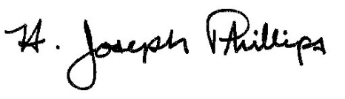 By:__H. Joseph Phillips___________

Title: _Historic Officer____________

Date of Meeting: April 3, 2019

