RESOLUTION NO.__________

RE: CERTIFICATE OF APPROPRIATENESS UNDER THE
PROVISIONS OF THE ACT OF THE PENNSYLVANIA
LEGISLATURE 1961, JUNE 13, P.L. 282 (53
SECTION 8004) AND BETHLEHEM ORDINANCE NO.
3952 AS AMENDED.

The applicant proposes to replace a pair of secondary entrance/exit doors at 424 Center St.

NOW, THEREFORE, BE IT RESOLVED by the Council of the City of Bethlehem that a Certificate of Appropriateness is hereby granted for the proposal.

Sponsored by: (s)

(s)

ADOPTED BY COUNCIL THIS DAY OF

(s)
President of Council

ATTEST:

(s)
City Clerk

HISTORICAL & ARCHITECTURAL REVIEW BOARD

The applicant proposes to replace a pair of secondary entrance/exit doors at 424 Center St.

APPLICATION #2:

Universal Universalist Church of the Lehigh Valley
424 Center St.
Bethlehem, PA 18018

OWNER:

__________________________________________________________________________

The Board upon motion by Phil Roeder and seconded by Connie Glagola adopted the proposal that City Council issue a Certificate of Appropriateness for the following:

1. The doors shall be manufactured as in-kind as possible with dimension and
proportions that replicate the existing doors.

2. Color of the doors to be Terra Cotta #394F068 by Oldcastle Building Envelope.

3. Door hardware will be as shown in presented sample.

4. The motion was unanimously approved.

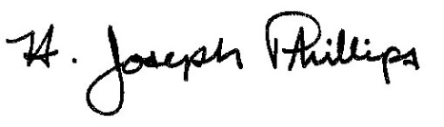 By:__H. Joseph Phillips___________

Title: _Historic Officer____________

Date of Meeting: April 3, 2019

