RESOLUTION NO.__________

RE: CERTIFICATE OF APPROPRIATENESS UNDER THE
PROVISIONS OF THE ACT OF THE PENNSYLVANIA
LEGISLATURE 1961, JUNE 13, P.L. 282 (53
SECTION 8004) AND BETHLEHEM ORDINANCE NO.
3952 AS AMENDED.

The applicant proposes to install a new wooden fence along the North or rear property fronting Milton St. and at the South of the property facing 225 E. Wall St.

NOW, THEREFORE, BE IT RESOLVED by the Council of the City of Bethlehem that a Certificate of Appropriateness is hereby granted for the proposal.

Sponsored by: (s)

(s)

ADOPTED BY COUNCIL THIS DAY OF

(s)
President of Council

ATTEST:

(s)
City Clerk

HISTORICAL & ARCHITECTURAL REVIEW BOARD

The applicant proposes to install a new wooden fence along the North or rear property fronting Milton St. and at the South of the property facing 225 E. Wall St.

APPLICATION #1:

Stephen Palone
225 East Wall St.
Bethlehem, PA 18018

OWNER:

__________________________________________________________________________

The Board upon motion by Marsha Fritz and seconded by Jennifer Rowe Hawk adopted the proposal that City Council issue a Certificate of Appropriateness for the following:

1. To install a wooden fence with a 3’-0” wide gate.

2. Use two coats of a solid stain.

3. The wood will be cedar.

4. The motion was unanimously approved.

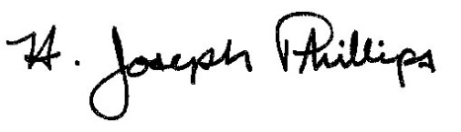 By:__H. Joseph Phillips___________

Title: _Historic Officer____________

Date of Meeting: April 3, 2019

