RESOLUTION NO.__________

RE: CERTIFICATE OF APPROPRIATENESS UNDER THE
PROVISIONS OF THE ACT OF THE PENNSYLVANIA
LEGISLATURE 1961, JUNE 13, P.L. 282 (53
SECTION 8004) AND BETHLEHEM ORDINANCE NO.
3952 AS AMENDED.

The Applicant proposes to change the awning fabric color at 428-444 Main St. (Moravian Bookstore).

NOW, THEREFORE, BE IT RESOLVED by the Council of the City of Bethlehem that a Certificate of Appropriateness is hereby granted for the proposal.

Sponsored by: (s)

(s)

ADOPTED BY COUNCIL THIS DAY OF

(s)
President of Council

ATTEST:

(s)
City Clerk

HISTORICAL & ARCHITECTURAL REVIEW BOARD

The Applicant proposes to change the awning fabric color at 428-444 Main St. (Moravian Bookstore).
APPLICATION #3-7

Moravian College
1200 Main St.
Bethlehem, PA 18018

OWNER:

__________________________________________________________________________

The Board upon motion by Genevieve Marcon and seconded by Diana Hodgson adopted the proposal that City Council issue a Certificate of Appropriateness for the following:

1. The installation of Silver Tweed Tempotest 47 awning fabric by the Miami
Corporation in place of the light blue fabric.

3. The motion was unanimously approved.

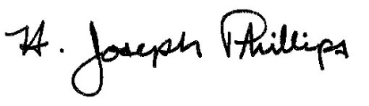 By:__H. Joseph Phillips___________

Title: __Historic Officer____________
Date of Meeting: February 6, 2019

