RESOLUTION NO.__________

RE: CERTIFICATE OF APPROPRIATENESS UNDER THE
PROVISIONS OF THE ACT OF THE PENNSYLVANIA
LEGISLATURE 1961, JUNE 13, P.L. 282 (53
SECTION 8004) AND BETHLEHEM ORDINANCE NO.
3952 AS AMENDED.

The Applicant proposes to eliminate door hardware on the north side of the entrance alcove at 428-444 Main St. (Moravian Bookstore).

NOW, THEREFORE, BE IT RESOLVED by the Council of the City of Bethlehem that a Certificate of Appropriateness is hereby granted for the proposal.

Sponsored by: (s)

(s)

ADOPTED BY COUNCIL THIS DAY OF

(s)
President of Council

ATTEST:

(s)
City Clerk

HISTORICAL & ARCHITECTURAL REVIEW BOARD

The Applicant proposes to eliminate door hardware on the north side of the entrance alcove at 428-444 Main St. (Moravian Bookstore).
APPLICATION #3-6

Moravian College
1200 Main St.
Bethlehem, PA 18018

OWNER:

__________________________________________________________________________

The Board upon motion by Genevieve Marcon and seconded by Marsha Fritz adopted the proposal that City Council issue a Certificate of Appropriateness for the following:

1. The door hardware will be eliminated on the exterior side of the pair of doors on the north
side of the entrance alcove.

2. The pair of doors will be exit only and a sign stating such will be located on the interior of the building, just inside these doors and clearly visible from the exterior.
3. The existing door hardware will be retained in storage in the event that it will need to be reinstalled in the future.
4. The motion was unanimously approved.

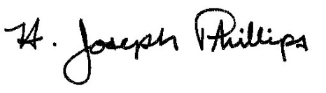 By:__H. Joseph Phillips___________

Title: __Historic Officer____________
Date of Meeting: February 6, 2019

