RESOLUTION NO.__________

RE: CERTIFICATE OF APPROPRIATENESS UNDER THE
PROVISIONS OF THE ACT OF THE PENNSYLVANIA
LEGISLATURE 1961, JUNE 13, P.L. 282 (53
SECTION 8004) AND BETHLEHEM ORDINANCE NO.
3952 AS AMENDED.

The Applicant proposes to install tenant signage (entry doors) at 428-444 Main St. (Moravian Bookstore).

NOW, THEREFORE, BE IT RESOLVED by the Council of the City of Bethlehem that a Certificate of Appropriateness is hereby granted for the proposal.

Sponsored by: (s)

(s)

ADOPTED BY COUNCIL THIS DAY OF

(s)
President of Council

ATTEST:

(s)
City Clerk

HISTORICAL & ARCHITECTURAL REVIEW BOARD

The Applicant proposes to install tenant signage (entry doors) at 428-444 Main St. (Moravian Bookstore).
APPLICATION #3-3

Moravian College
1200 Main St.
Bethlehem, PA 18018

OWNER:

__________________________________________________________________________

The Board upon motion by Beth Starbuck and seconded by Diana Hodgson adopted the proposal that City Council issue a Certificate of Appropriateness for the following:

1. Install tenant signage on the entry doors with the graphics or text to be creamy white, off white or light gray.
2. The motion was unanimously approved.

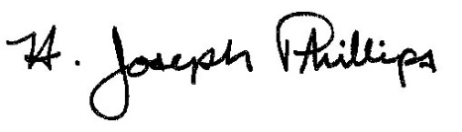 By:__H. Joseph Phillips___________

Title: __Historic Officer____________

Date of Meeting: February 6, 2019

