RESOLUTION NO.__________

RE: CERTIFICATE OF APPROPRIATENESS UNDER THE
PROVISIONS OF THE ACT OF THE PENNSYLVANIA
LEGISLATURE 1961, JUNE 13, P.L. 282 (53
SECTION 8004) AND BETHLEHEM ORDINANCE NO.
3952 AS AMENDED.

The Applicant proposes to replace exterior tile at 428-444 Main St. (Moravian Bookstore).

NOW, THEREFORE, BE IT RESOLVED by the Council of the City of Bethlehem that a Certificate of Appropriateness is hereby granted for the proposal.

Sponsored by: (s)

(s)

ADOPTED BY COUNCIL THIS DAY OF

(s)
President of Council

ATTEST:

(s)
City Clerk

HISTORICAL & ARCHITECTURAL REVIEW BOARD

The Applicant proposes to replace exterior tile at 428-444 Main St. (Moravian Bookstore).
APPLICATION #3-2

Moravian College
1200 Main St.
Bethlehem, PA 18018

OWNER:

__________________________________________________________________________

The Board upon motion by Beth Starbuck and seconded by Marsha Fritz adopted the proposal that City Council issue a Certificate of Appropriateness for the following:

1. All tile and grout materials will be frost-proof.
2. Tiles will be 3” x 3” with dark gray, light gray and cream colored tiles surrounding a 6’6” medallion. The grout color will be between dark and light gray.
3. The motion was unanimously approved.

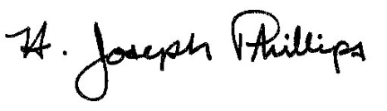 By:__H. Joseph Phillips___________

Title: __Historic Officer____________

Date of Meeting: February 6, 2019

