RESOLUTION NO.__________

RE: CERTIFICATE OF APPROPRIATENESS UNDER THE
PROVISIONS OF THE ACT OF THE PENNSYLVANIA
LEGISLATURE 1961, JUNE 13, P.L. 282 (53
SECTION 8004) AND BETHLEHEM ORDINANCE NO.
3952 AS AMENDED.

WHEREAS, it is proposed to secure a COA to re-vinyl the existing sign face at 736 East Fourth Street (Las Americas Bakery).

NOW, THEREFORE, BE IT RESOLVED by the Council of the City of Bethlehem that a Certificate of Appropriateness is hereby granted for the proposal.

Sponsored by: (s)

(s)

ADOPTED BY COUNCIL THIS DAY OF

(s)
President of Council

ATTEST:

(s)
City Clerk

HISTORIC CONSERVATION COMMISSION

CASE #678 -- It is proposed to re-vinyl the existing sign face at 736 East Fourth Street (Las Americas Bakery).

OWNER / APPLICANT: Lehigh Valley 4 Rent / Francisco Mendez

The Commission upon motion by Mr. Evans and seconded by Mr. Hudak adopted the proposal that City Council issue a Certificate of Appropriateness for the proposed work as presented (with modifications) described herein:

- The proposal to install new building signage was presented by Francisco Mendez (accompanied by son as translator).
- New signage includes:
  - replacement vinyl face over existing signage with new business name; overall dimensions of sign are 24” tall x 144” wide
  - new sign includes “Las Americas Bakery” in large stylized serif lettering printed above slogan “Finest Baked Goods” in smaller serif lettering … all lettering depicted in dark brown color
  - sign background is off white in color and pinstripe border offset from edge of sign is in dark brown color to match lettering; rounded-off corner details of original sign to be retained with new signage
- The motion for the proposed work was unanimously approved.

JBL: jbl
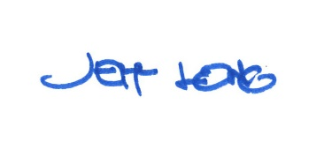

By:

Date of Meeting: December 17, 2018 Title: Historic Officer

