RESOLUTION NO.__________

RE: CERTIFICATE OF APPROPRIATENESS UNDER THE
PROVISIONS OF THE ACT OF THE PENNSYLVANIA
LEGISLATURE 1961, JUNE 13, P.L. 282 (53
SECTION 8004) AND BETHLEHEM ORDINANCE NO.
3952 AS AMENDED.

WHEREAS, it is proposed to install signs at 21 E. Third Street.

NOW, THEREFORE, BE IT RESOLVED by the Council of the City of Bethlehem that a Certificate of Appropriateness is hereby granted for the proposal.

Sponsored by: (s)

(s)

ADOPTED BY COUNCIL THIS DAY OF

(s)
President of Council

ATTEST:

(s)
City Clerk

HISTORIC CONSERVATION COMMISSION

CASE # 636– It is proposed to install signs at 21 E. Third Street.
OWNER/APPLICANT: John Saraceno/Domaci

The Commission upon motion by Mr. Evans seconded by Mr. Lader adopted the proposal that City Council issue a Certificate of Appropriateness for the proposed work described herein:

- The proposal to install signs at 21 E. Third Street was represented by Derrick Clark.
- The new wall sign above the first floor storefront will be 120”x42” in size, fabricated of a composite panel material, and built over the remaining box portion of the former Cleo’s sign.
- The sign will read “Domaci” in white, 2” deep stainless steel letters on a wood graphic print background. The letters will be backlit/halo lit with white LED lights.
- There will also be two 34”x17” white vinyl window signs installed in two display windows as shown in the renderings submitted.
- Any damage to the existing sign band must be repaired.
- The motion to approve the proposed work was unanimously approved.

CU: cu
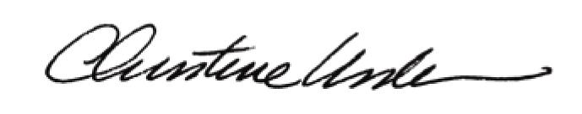

By:

Date of Meeting: December 18, 2017 Title: Historic Officer

