RESOLUTION NO.__________

RE: CERTIFICATE OF APPROPRIATENESS UNDER THE
PROVISIONS OF THE ACT OF THE PENNSYLVANIA
LEGISLATURE 1961, JUNE 13, P.L. 282 (53
SECTION 8004) AND BETHLEHEM ORDINANCE NO.
3952 AS AMENDED.

The applicant proposes to remove and replace the windows at 56 E. Wall Street.

NOW, THEREFORE, BE IT RESOLVED by the Council of the City of Bethlehem that a Certificate of Appropriateness is hereby granted for the proposal.

Sponsored by: (s)

(s)

ADOPTED BY COUNCIL THIS DAY OF

(s)
President of Council

ATTEST:

(s)
City Clerk

HISTORICAL & ARCHITECTURAL REVIEW BOARD

The applicant proposes to remove and replace the windows at 56 E. Wall Street.
APPLICATION #3:

Louis Cinquino
56 E. Wall St.
Bethlehem, PA 18018

OWNER:

__________________________________________________________________________

The Board upon motion by Phil Roeder and seconded by Marsha Fritz adopted the proposal that City Council issue a Certificate of Appropriateness for the following:

1. Replace existing windows with Anderson Woodright Series 400 windows.

2. Windows to be wood and painted to match existing.

3. The existing casings will be retained when possible and painted white.

4. The motion was unanimously approved.

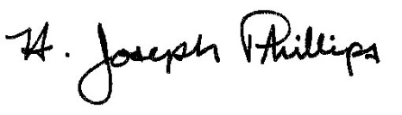 By:__ H. Joseph Phillips___________
Title: _Historic Officer____________
Date of Meeting: September 4, 2019

