RESOLUTION NO.__________

RE: CERTIFICATE OF APPROPRIATENESS UNDER THE
PROVISIONS OF THE ACT OF THE PENNSYLVANIA
LEGISLATURE 1961, JUNE 13, P.L. 282 (53
SECTION 8004) AND BETHLEHEM ORDINANCE NO.
3952 AS AMENDED.

The applicant proposes to remove slate roofing on the shed and replace with GAF Slateline shingles at 46 E. Church St.

NOW, THEREFORE, BE IT RESOLVED by the Council of the City of Bethlehem that a Certificate of Appropriateness is hereby granted for the proposal.

Sponsored by: (s)

(s)

ADOPTED BY COUNCIL THIS DAY OF

(s)
President of Council

ATTEST:

(s)
City Clerk

HISTORICAL & ARCHITECTURAL REVIEW BOARD

The applicant proposes to remove slate roofing on the shed and replace with GAF Slateline shingles at 46 E. Church St.

APPLICATION #2:

Charles F. Lieb
46 E. Church St.
Bethlehem, PA 18018

OWNER:

__________________________________________________________________________

The Board upon motion by Phil Roeder and seconded by Connie Postupack adopted the proposal that City Council issue a Certificate of Appropriateness for the following:

1. Slate roof is to be removed on the shed and replaced with GAF Slateline shingles.

2. Shingle color is to be Slate Grey.

3. Appropriate hip ridge shingles are to be installed at the intersection of the roof
planes.

4. Existing gutters are half-round and will be replaced in-kind.

4. The motion was unanimously approved.

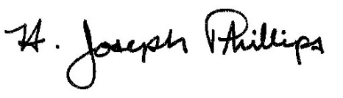 By:__ H. Joseph Phillips___________
Title: _Historic Officer____________
Date of Meeting: September 4, 2019

