RESOLUTION NO.__________

RE: CERTIFICATE OF APPROPRIATENESS UNDER THE
PROVISIONS OF THE ACT OF THE PENNSYLVANIA
LEGISLATURE 1961, JUNE 13, P.L. 282 (53
SECTION 8004) AND BETHLEHEM ORDINANCE NO.
3952 AS AMENDED.

The applicant proposes to install a wooden fence and wooden gate with two wood fence posts at 251 E. Church St.

NOW, THEREFORE, BE IT RESOLVED by the Council of the City of Bethlehem that a Certificate of Appropriateness is hereby granted for the proposal.

Sponsored by: (s)

(s)

ADOPTED BY COUNCIL THIS DAY OF

(s)
President of Council

ATTEST:

(s)
City Clerk

HISTORICAL & ARCHITECTURAL REVIEW BOARD

The applicant proposes to install a wooden fence and wooden gate with two wood fence posts at 251 E. Church St.

APPLICATION #1:

Madeline Peters
251 E. Church Street
Bethlehem, PA 18018

OWNER:

__________________________________________________________________________

The Board upon motion by Marsha Fritz and seconded by Derrick Clark adopted the proposal that City Council issue a Certificate of Appropriateness for the following:

1. The fence posts are to be installed on the applicant’s side of the fence and away
from the neighbor.

2. All fence posts shall have wood caps to match the fence.

3. The fence shall be located a minimum of 6 inches from the property line.

4. The fence will be 6’-0” high and finished with a clear finish on all sides of the fence
gate and posts within one year of installation.

5. The fence will be cedar and the hardware and post caps will be black in color.

6. The result of the vote was 6 members in favor and 2 members against to approve
the motion.

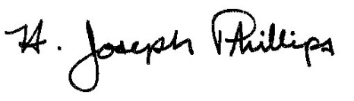 By:__ H. Joseph Phillips___________
Title: _Historic Officer____________
Date of Meeting: September 4, 2019

