RESOLUTION NO.__________

RE: CERTIFICATE OF APPROPRIATENESS UNDER THE
PROVISIONS OF THE ACT OF THE PENNSYLVANIA
LEGISLATURE 1961, JUNE 13, P.L. 282 (53
SECTION 8004) AND BETHLEHEM ORDINANCE NO.
3952 AS AMENDED.

WHEREAS, it is proposed to secure a COA to install signage per elevations and plans at 306 South New Street (ZEST Bar & Grille).

NOW, THEREFORE, BE IT RESOLVED by the Council of the City of Bethlehem that a Certificate of Appropriateness is hereby granted for the proposal.

Sponsored by: (s)

(s)

ADOPTED BY COUNCIL THIS DAY OF

(s)
President of Council

ATTEST:

(s)
City Clerk

HISTORIC CONSERVATION COMMISSION

CASE #700 -- It is proposed to install signage per elevations and plans at 306 South New Street (ZEST Bar & Grille).

OWNER / APPLICANT: Greenway 1, Inc. / John Trapani

The Commission upon motion by Ms. Starbuck and seconded by Mr. Evans adopted the proposal that City Council issue a Certificate of Appropriateness for the proposed work as presented and described herein:

- The proposal to install signage per elevations and plans was presented by John Trapani.
- Approved improvements include:
  - existing sign composed of individual letters spelling out “ZEST” company logo in large sans-serif, stenciled, all-capital letters in bright white color as supplemental building signage; color of letters is not reflective and signage will not be illuminated
  - lettering installed on inside surfaces of glass panels (part of handrail assembly) along west façade of sixth floor outdoor dining terrace
  - each letter measures 41 inches high x 28.5 inches wide and is centered horizontally as well as vertically within respective panel
- The motion for the proposed work was approved 7-0-1, with Mr. Lader abstaining.

JBL: jbl
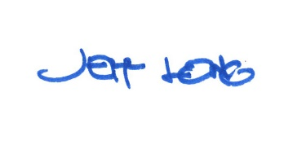

By:

Date of Meeting: September 16, 2019

